# Make a Minibeast Hibernation Homeladybird

Lots of minibeasts (invertebrates) love our gardens, including useful and attractive species like ladybirds. One way we can encourage minibeasts to visit, or to stay a bit longer is to make a safe place for them to spend the colder winter.

Compost heaps and piles of logs are the kind of natural places they like to stay, they love to crawl in between sticks and twigs where it is warmer and sheltered. Making your own minibeast hibernation home will provide additional places for them to stay, it’s great fun too.

Your hibernation home can be as large or as small as you like, just make sure you have lots of little spaces for the minibeasts to crawl into.

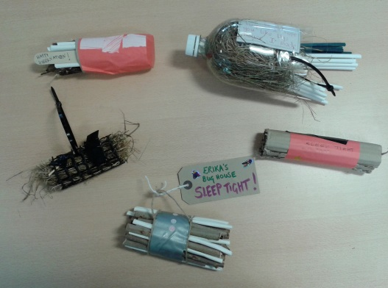 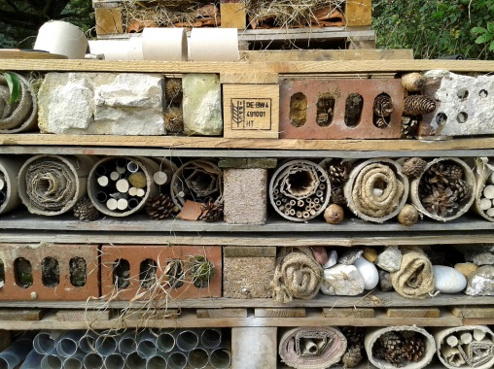

Minibeasts have their own special requirements when looking for a home so if you can use different materials you will attract different insects. Here are some suggestions -

* **Straw or wood** is loved by pretty **lacewings**, whose larvae feed on many pests: aphids, obscure mealy bugs, whiteflies, thrips or acari eggs and other burrowing insects.
* **Bamboo rods** and **drilled logs**provide shelter for solitary bees and wasps like the **mason bee**, that pollinate the first flowers of fruit trees and whose larvae feed on aphids.
* **Flower pots filled with hay** attract **earwigs** who also feed on pests. An upside down flower pot might also attract a queen bee.
* **Wooden boards**will attract **xylophagous insects** that decompose dead wood.
* **Bundles of pith rods** such as the bramble, rose, elderberry provide ideal shelter for **hoverflies** and **other Hymenoptera**.
* **Bricks**, **stones and roof tiles**would be appreciated by amphibians such as frogs and newts that will rest and hibernate amongst damp places.
* **Dead wood, especially with bark,** provides lots of nooks and crannies for **ladybirds** to hibernate in. Their larvae consume a lot of aphids.

For best results, put your hibernation home on the ground in a fairly dry, sheltered place near some vegetation, like the bottom of a hedge during the autumn. Hang, or place your insect house in a warm sunny position with the end pointing down slightly to let moisture out. Invertebrates should hopefully move in and will emerge again in the spring.

If you are curious, in the spring gently tap the end of the tube onto a sheet of white paper to see what is inside. Be gentle with anything you find and make sure you return the creatures to the place you find them though!

Please upload any photos of hibernation homes you make to [www.bnhs.co.uk/youngnats/contactus/](http://www.bnhs.co.uk/youngnats/contactus/)